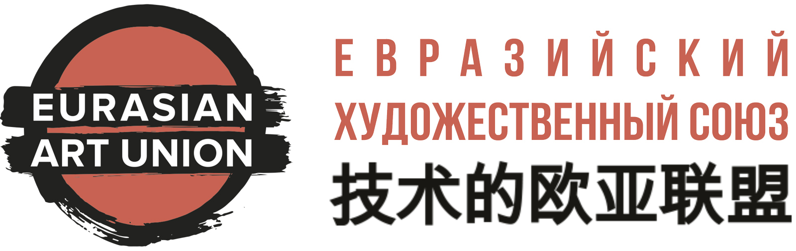 | РОО ТС «Евразийский художественный союз»  ИНН 7723471572, КПП 772301001, ОГРН 1167700064070  Tel.: +7 985 4811118,  Whatsapp: +7 925 4338821  E-mail: info@artunion.pro  www.artunion.pro
QUESTIONNAIRE FOR CREATING CREATIVE AUTOBIOGRAPHY
The Eurasian Art Union offers its members and candidates to create a professional creative autobiography (CV), which will reflect the best aspects of personality and creativity. The design studio of the Eurasian Art Union will help you create such a document. We will create it in two languages - Russian and English. If desired, it is possible to form an autobiography in other languages: Chinese, Arabic, Spanish, Italian, German and French.
Professional illustrated autobiography - your must-have tool for creative and professional growth!
Attention:
a) Fill in only those sections that you would like to reflect in your autobiography (for example, if you specify a phone number and email, they will be visible to everyone);
b) if you already have professional translations, then fill out two forms: one in Russian, the second in a foreign language;
c) authors who professionally speak several languages are invited to cooperate.
What autobiography would you like to receive:
Strict style: ___ | Art style: ___ | No artworks photos ___ | With artworks photos ___
Autobiography:
Full name:
Alias:
Contacts: (fill in only those items that should be visible to a wide audience)
Phone:
E-mail:
Personal site:
Social Media Links:
BRIEF ABOUT YOURSELF:
INDIVIDUAL QUALITIES:
SKILLS:
Education:
№ | Graduation year: | Educational Institution: | Professional Specialty:
1
2
3
Work Experience:
№ | Dates: | Place of work:
1
2
3
ACHIEVEMENTS, AWARDS, CERTIFICATES, DIPLOMAS:
№ | Year: | Title:
1
2
3
Publication:
№ | Year: | Title:
1
2
3
RECOMMENDATIONS: (Reviews, articles, reviews about your work, quotes)
№ | From who: | Recomendation:
1
2
3

Full name: Date of filling in:

